Instructions on How to Submit High School Student Consent for Release of Records

Why do I need to complete this Consent Form?
Your consent is needed for RCC to send your college grades to your high school. Without the grade, the high school can’t give you credit for completing the class.
To complete the form:
Go to www.rockinghamcc.edu
Click “MyRCCLogin”
Click “Etrieve Central” under the “Student” tab. You will be directed to the
login screen.

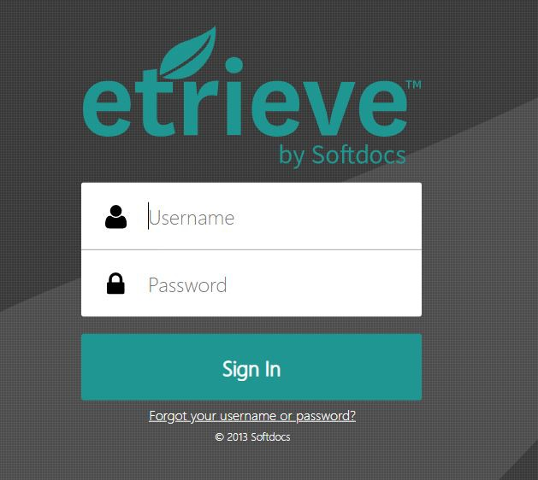

Login using the following information:

Username: last name, first initial and last four digits of ID # (ex. evansc1234)

Password: The password is the same as you use for your student email

Once you login, you will see the Etrieve Central Dashboard:

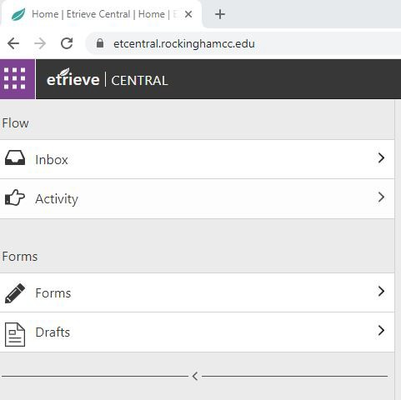

Click the arrow beside forms and the forms you have access to will be displayed.
Click on: “High School Student Consent for Release of Records”
When the form opens, the date, your name and RCC ID will automatically populate for you. You must complete the address information.
Click the box under “Release Information To”. High school options will appear. Click on the name of the High School you attend. Address Information will automatically populate for you.
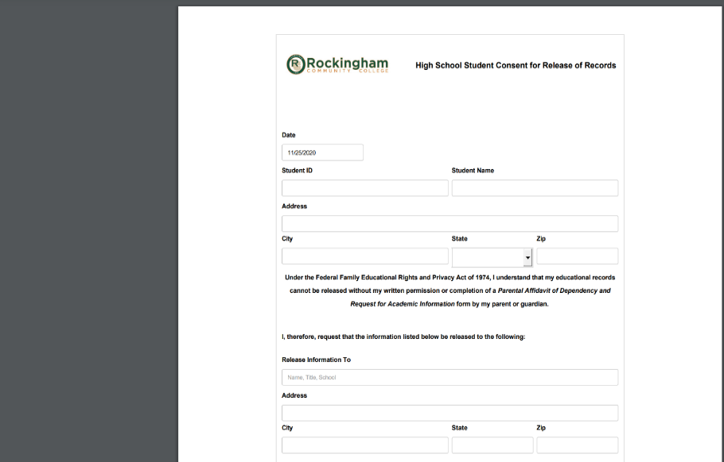

Read the “Information to be released and “Purposes” sections
Check the box beside the statement” Checking this box acknowledges my electronic signature attesting to the form’s accuracy”

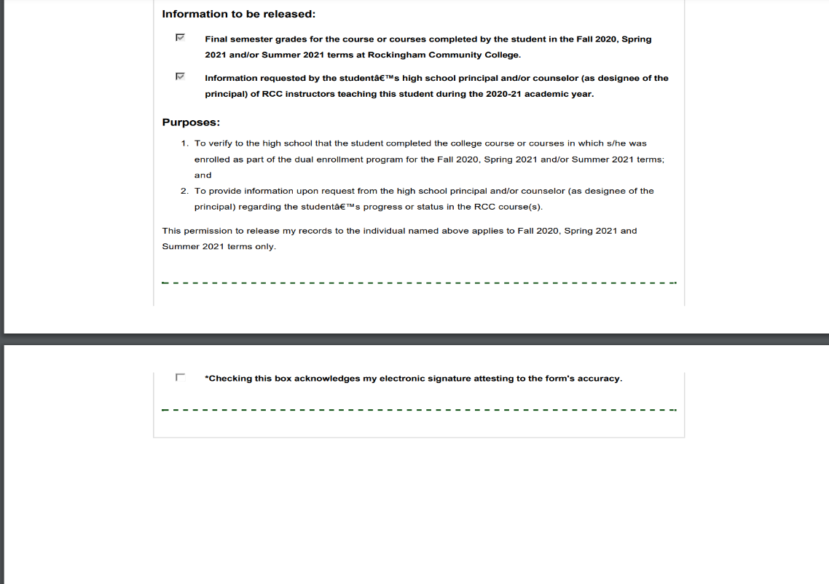

Click “Submit” at the bottom of the Etrieve page to submit the form.

